***push button switch interface- door bell control***

**Circuit Diagram**:

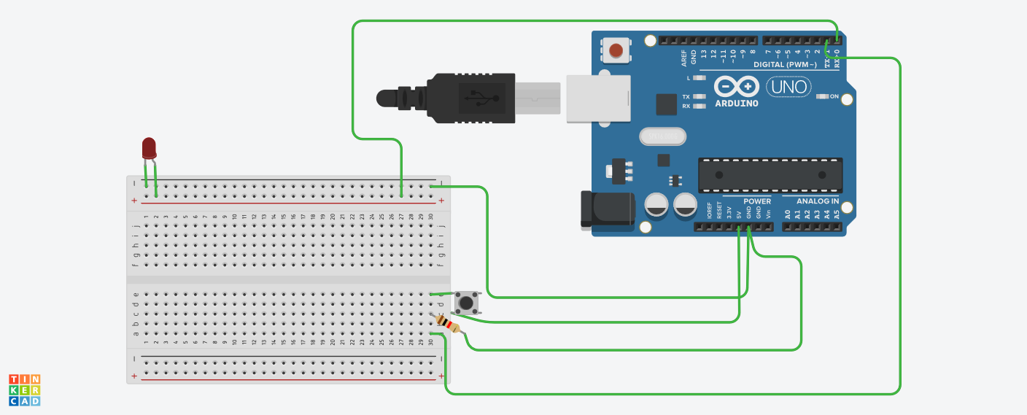

**Theory:**

Concepts Used:

1. Using of push button.
2. Coding Arduino.

**Learning & Observations**:

Learned the use of switch.Understood the use of switch to turn on and off led.

**Problems & Troubleshooting**

Unknowingly the connections of switch were made wrong.

Made the circuit right later.

**Precautions**

1. Check the LED,arduino and switch are working properly.
2. Declare pins used .
3. Make the connections of switch correctly.

**Learning Outcomes**

Learned usage of switch it was very fun.

Learned the use of breadboard and LED.